
Press Release
FOR IMMEDIATE RELEASE

More men are actively investing in their health than ever before. Is your practice ready to meet the demand?

New multidisciplinary conference will help healthcare professionals better understand, engage and support one of healthcare's fastest-growing patient groups: MEN.
[LONDON: AUGUST 2026] More men are taking a proactive approach to their health and wellbeing and seeking trusted advice on everything from hair loss, skin health and weight management to testosterone, metabolic health and healthy ageing.
Yet while demand for men's health services continues to grow, many healthcare professionals have had little formal education on how to effectively engage, communicate with and care for this evolving patient group.
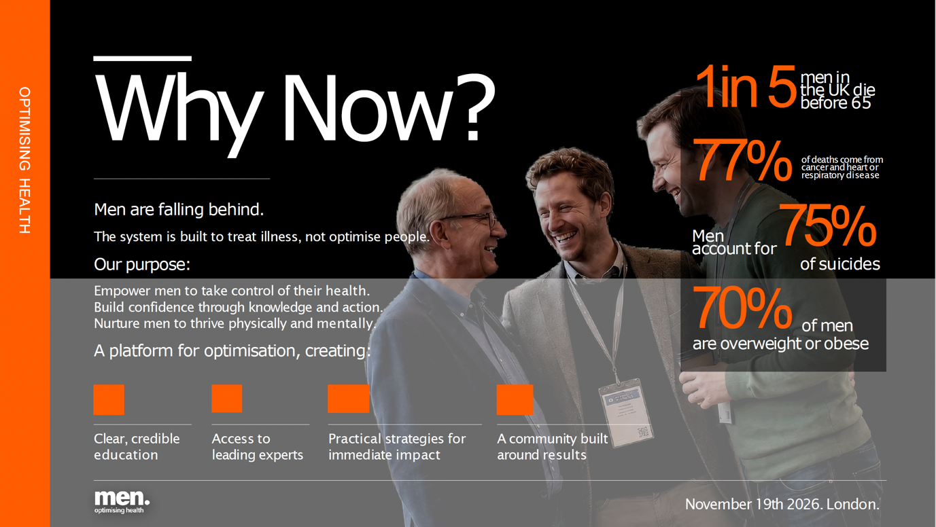
MEN: Optimising Health has been created to help bridge that gap.
Developed by The Health Assembly, the team behind market-leading events including Menopause in Practice, PAUSE Live and Future Patient, the new one-day conference taking place on International Men's Day (November 19, 2026), will bring together experts from endocrinology, longevity medicine, lifestyle medicine, aesthetics, primary care and preventative health to explore not only the latest clinical evidence, but also how practices can better understand, engage and support male patients through ethical, evidence-based care.
Chaired by Professor Syed Haq, Professor of Medicine and expert in healthy ageing and preventative medicine, and Dr Masud Haq, Consultant in Diabetes and Endocrinology and Founder of the Wellness Hormone Clinic, the conference will explore many of the most important issues shaping modern men's health.
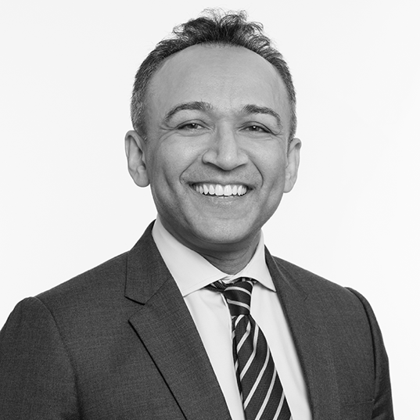
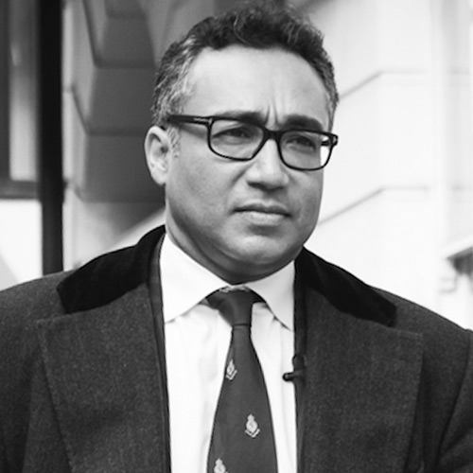

Sessions will cover topics including:
- Metabolic health and nutrition
- Mental health and suicide prevention
- Male hormones and testosterone deficiency
- Erectile dysfunction
- Hair loss
- Diagnostic testing and personalised medicine
- Regenerative medicine
- Aesthetic medicine
- PRP in men's health
- Marketing healthcare services to male patients
Designed for GPs, nurses, specialist clinicians, lifestyle medicine practitioners, aesthetic practitioners and allied healthcare professionals, MEN is for both practices already supporting significant numbers of male patients and those looking to develop this growing area of healthcare.
Alongside the latest clinical evidence, delegates will gain practical insights into how to better understand men's health needs, communicate more effectively with male patients, create services that genuinely meet their needs and build long-term patient relationships.
Charlotte Body, Founder of The Health Assembly, said: “We're witnessing a real shift in the way men engage with their health. More are actively looking for trusted advice on everything from skin health and hair restoration to hormones, weight management, longevity and preventative healthcare. But too often those conversations are still happening too late – or they're happening on social media instead of in the consulting room.
"We've seen how dedicated education has transformed menopause care over the past decade, and we believe men's health is reaching a similar turning point. MEN has been created to give clinicians the confidence, knowledge and practical tools to respond to this growing demand responsibly.”
The conference is being delivered in partnership with headline sponsor PHC Personalised Health Clinics, reflecting a shared commitment to preventative, personalised healthcare and helping people take control of their health before illness develops.
Delegates will have the opportunity to hear from leading experts, gain practical clinical insights, network with peers from across multiple disciplines and earn up to 12 hours of CPD accreditation. Whether they are expanding existing men's health services or looking to welcome more male patients into their practice, attendees will leave with practical strategies they can immediately implement.
In the evening, following the professional conference, there will be a dedicated consumer event, offering men the chance to experience relaxed, podcast-style conversations with leading experts on hormones, longevity, nutrition, mental wellbeing and healthy ageing.
Registration is now open. Tickets cost £199 and are available at www.menevent.co.uk

