
Press Release
FOR IMMEDIATE RELEASE

MEN launches a new live experience for men who want to optimise their health
New consumer men’s event will bring together some of the UK's leading experts for an evening of honest conversations about men's health, aesthetics, longevity and performance.
[LONDON: AUGUST 2026] Imagine sitting in the audience of your favourite health podcast, listening to candid conversations with some of the UK's leading experts as they tackle the questions many men are already searching for online.
That is the vision behind MEN: Optimising Health, a brand-new live event taking place in London on International Men's Day – Thursday, November 19, 2026.
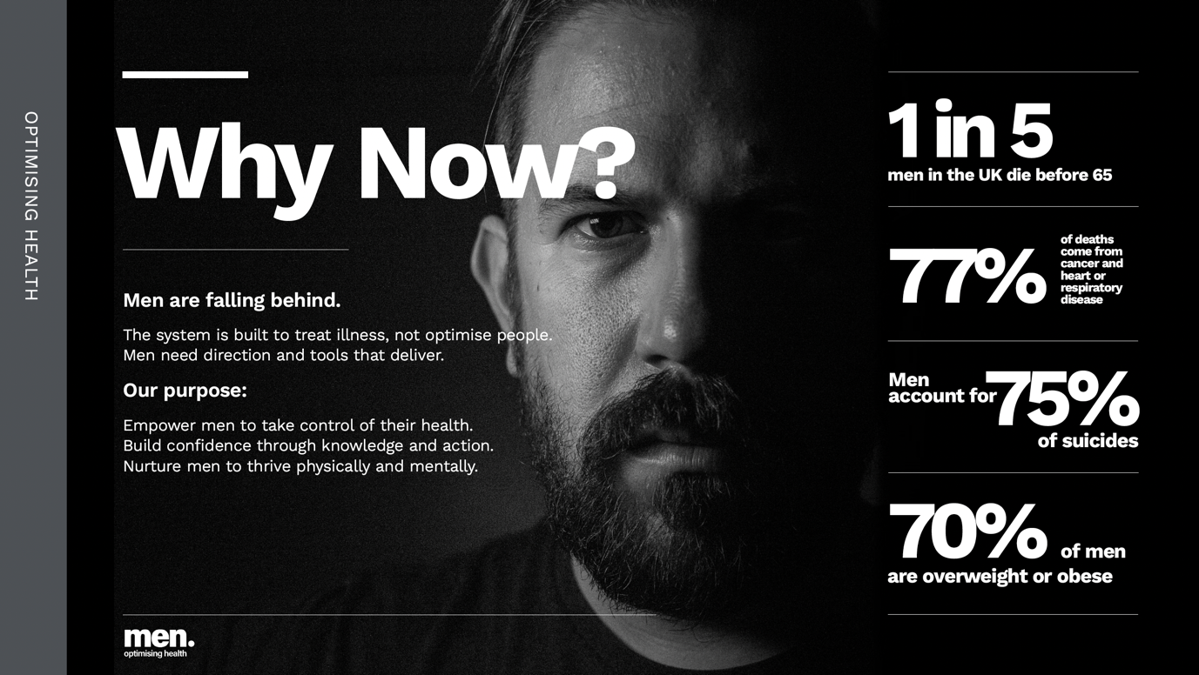
Created by The Health Assembly, the evening event has been designed to help men better understand their health, challenge outdated attitudes and discover practical ways to improve how they look, feel and perform throughout midlife and beyond.
Alongside a daytime conference for healthcare professionals, MEN will open its doors in the evening to consumers, creating a unique opportunity for the public to hear directly from respected clinicians, health and wellness experts and special guests.
The event will feature relaxed, podcast-style conversations exploring the topics that men are increasingly curious about – but often struggle to discuss openly.
From hormones and testosterone, loss of libido, erectile dysfunction, metabolic health and nutrition to mental wellbeing, hair loss, fitness, healthy ageing and the future of personalised medicine, the programme will tackle the issues shaping modern men's health.
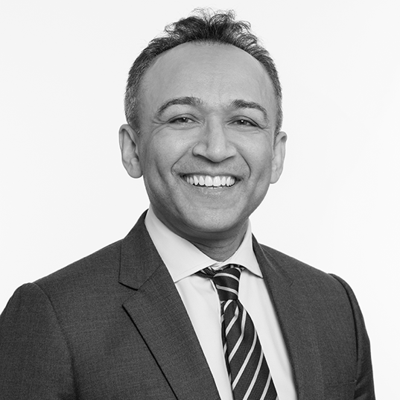
The event will be chaired by Professor Syed Haq and Dr Masud Haq, with additional speakers to be announced over the coming months. James Davis, founder of The Midlife Mentor, has already been confirmed as a key part of the consumer programme, with further well-known guests and special appearances planned.
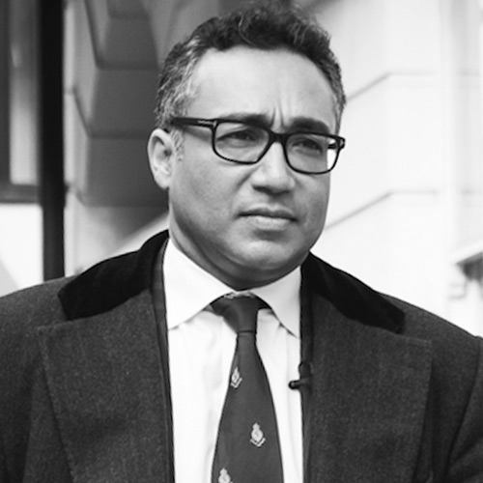

Charlotte Body, founder of The Health Assembly, said: “Men's health has been shaped by silence for far too long. Too many men delay seeking help because they feel they should cope on their own, while others simply don't know where to turn for trustworthy advice. We want MEN to become a place where those barriers start to come down. By creating open, evidence-based conversations in a welcoming environment, we hope more men will feel confident to prioritise their health and ask the questions they've perhaps never felt comfortable asking before.”
The event is being delivered in partnership with headline sponsor PHC Personalised Health Clinics, whose focus on preventative, personalised healthcare reflects the event's mission of helping people take control of their long-term health before illness develops.
Whether attendees want to understand testosterone, improve their energy, optimise performance, address signs of ageing or simply separate evidence from online hype, MEN aims to provide practical, evidence-based information they can immediately put into action.
Tickets cost £89 and are available at www.menevent.co.uk

